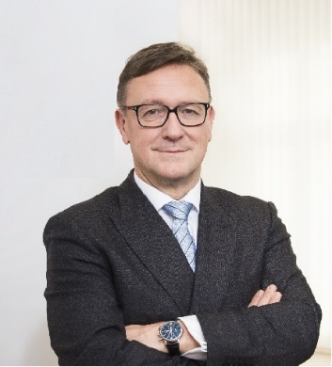 | Calendar of Helmut Ettl  Member of the Supervisory Board of the Single Supervisory Mechanism  Executive Director of the Austrian Financial Market Authority  October 2024
Date | Meeting / Event | Location
Tuesday, 1 October | Supervisory Board Meeting | Virtual
Wednesday, 2 October | Meeting with supervised entity | Vienna
Thursday, 3 October | Financial Markets Stability Board Meeting | Vienna
Tuesday, 8 October | FMA Supervisory Conference | Vienna
Thursday, 10 October | Strategic Retreat/Supervisory Board Meeting | Ljubljana
Friday, 11 October | Strategic Retreat/Supervisory Board Meeting | Ljubljana
Tuesday, 15 October | Meeting with supervised entity | Vienna
Wednesday, 16 October | EBA BoS Meeting | Paris
Thursday, 17 October | Panelist at “Banken-Symposium” Wachau | Furth
Friday, 18 October | Meeting with supervised entity | Vienna
Tuesday, 22 October | IIF Annual Membership Meeting | Washington, DC
Wednesday, 23 October | Meeting with representatives of the IMF | Washington, DC
Thursday, 24 October | Meeting with representatives of the FED | Washington, DC
Thursday, 24 October | Meeting with representatives of the IMF | Washington, DC
Wednesday, 30 October | Visit to Austria of the EBA-Chair | Vienna
Wednesday, 30 October | Meeting with the Austrian Chamber of Commerce | Vienna
Thursday, 31 October | Visit to Austria of the EBA-Chair | Vienna

The calendar gives information on Helmut Ettl’s meetings in his capacity as a member of the ECB’s Supervisory Board. It includes institutional meetings, speaking engagements, attendance at conferences and events, as well as appointments with external parties (incl. media), unless releasing the information could undermine the protection of public interests recognised at EU level. Internal Eurosystem meetings are not published.

