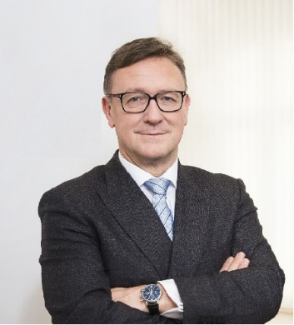 | Calendar of Helmut Ettl  Member of the Supervisory Board of the Single Supervisory Mechanism  Executive Director of the Austrian Financial Market Authority  November 2024
Date | Meeting / Event | Location
Tuesday, 5 November | Supervisory Board Meeting | Frankfurt
Wednesday, 6 November | Supervisory Board Meeting | Frankfurt
Thursday, 7 November | Interview with the media | Vienna
Monday, 11 November | Meetings with the European Commission | Brussels
Tuesday, 12 November | Meetings with the European Commission | Brussels
Wednesday, 13 November | Interview with the media | Vienna
Wednesday, 13 November | Meeting with supervised entity | Vienna
Thursday, 14 November | Speech at “Fachtagung für Sparkassen-/Aufsichtsrät:innen” hosted by Österreichischer Sparkassenverband | Vienna
Friday, 15 November | Meeting with Austrian Chamber of Commerce | Vienna
Tuesday, 19 November | EBA MB Meeting | Paris
Monday, 25 November | Finanzcockpit, hosted by OeNB | Virtual
Tuesday, 26 November | Participation at “4-Länder-Treffen” with BaFin, FINMA, FMA Liechtenstein | Vienna
Wednesday, 27 November | Participation at “4-Länder-Treffen” with BaFin, FINMA, FMA Liechtenstein | Vienna
Thursday, 28 November | ESRB GB Meeting | Virtual
Thursday, 28 November | Meeting with supervised entity | Vienna

The calendar gives information on Helmut Ettl’s meetings in his capacity as a member of the ECB’s Supervisory Board. It includes institutional meetings, speaking engagements, attendance at conferences and events, as well as appointments with external parties (incl. media), unless releasing the information could undermine the protection of public interests recognised at EU level. Internal Eurosystem meetings are not published.

