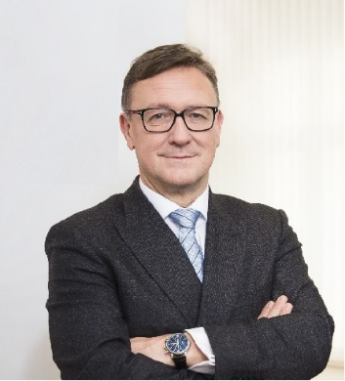 | Calendar of Helmut Ettl  Member of the Supervisory Board of the Single Supervisory Mechanism  Executive Director of the Austrian Financial Market Authority  December 2024
Date | Meeting / Event | Location
Monday, 2 December | Financial Markets Stability Board Meeting | Vienna
Monday, 2 December | Meeting with supervised entity | Vienna
Tuesday, 3 December | Interview with the media | Vienna
Wednesday, 4 December | Supervisory Board Meeting | Frankfurt
Thursday, 5 December | Supervisory Board Meeting | Frankfurt
Monday, 9 December | FMA-Press Conference on “Facts and Figures, Trends and Strategies 2025” | Vienna
Tuesday, 10 December | EBA BoS Meeting | Virtual
Wednesday, 11 December | Meetings with supervised entities | Vienna
Friday, 20 December | Interview with the media | Vienna

The calendar gives information on Helmut Ettl’s meetings in his capacity as a member of the ECB’s Supervisory Board. It includes institutional meetings, speaking engagements, attendance at conferences and events, as well as appointments with external parties (incl. media), unless releasing the information could undermine the protection of public interests recognised at EU level. Internal Eurosystem meetings are not published.

