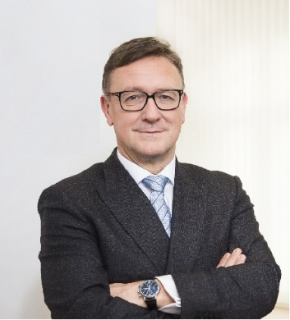 | Calendar of Helmut Ettl  Member of the Supervisory Board of the Single Supervisory Mechanism  Executive Director of the Austrian Financial Market Authority  January 2025
Date | Meeting / Event | Location
Thursday, 9 January | Meeting with supervised entity | Vienna
Wednesday, 15 January | Meeting with supervised entity | Vienna
Thursday, 16 January | SSM Supervisory Board Meeting | Virtual
Wednesday, 22 January | Meeting with the media | Vienna
Tuesday, 28 January | EBA MB Meeting | Paris

The calendar gives information on Helmut Ettl’s meetings in his capacity as a member of the ECB’s Supervisory Board. It includes institutional meetings, speaking engagements, attendance at conferences and events, as well as appointments with external parties (incl. media), unless releasing the information could undermine the protection of public interests recognised at EU level. Internal Eurosystem meetings are not published.

