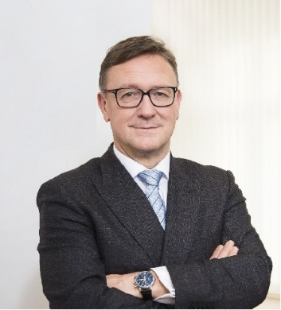 | Calendar of Helmut Ettl  Member of the Supervisory Board of the Single Supervisory Mechanism  Executive Director of the Austrian Financial Market Authority  February 2025
Date | Meeting / Event | Location
Monday, 3 February | Meeting with supervised entity | Vienna
Wednesday, 5 February | SSM Supervisory Board Meeting | Frankfurt
Thursday, 6 February | SSM Supervisory Board Meeting | Frankfurt
Wednesday, 12 February | Visit to Austria from DG FISMA | Vienna
Thursday, 13 February | EBA Board of Supervisors Meeting | Paris
Friday, 14 February | Interview with the media | Vienna
Monday, 17 February | Interview with the media | Vienna
Wednesday, 26 February | Financial Markets Stability Board Meeting | Virtual
Thursday, 27 February | Speech at on event organized by the Bankers’ Association | Vienna

The calendar gives information on Helmut Ettl’s meetings in his capacity as a member of the ECB’s Supervisory Board. It includes institutional meetings, speaking engagements, attendance at conferences and events, as well as appointments with external parties (incl. media), unless releasing the information could undermine the protection of public interests recognised at EU level. Internal Eurosystem meetings are not published.

