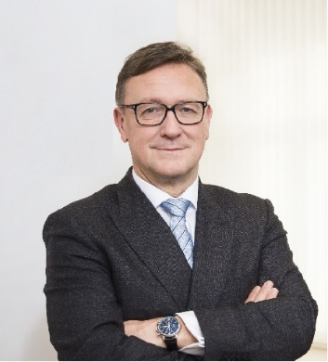 | Calendar of Helmut Ettl  Member of the Supervisory Board of the Single Supervisory Mechanism  Executive Director of the Austrian Financial Market Authority  March 2025
Date | Meeting / Event | Location
Tuesday, 4 March | Meeting with the Chair of Bankers’ Association | Vienna
Thursday, 6 March | Meeting with supervised entity | Vienna
Tuesday, 11 March | EBA MB Meeting | Virtual
Wednesday, 19 March | Meeting with AMLA Chair | Frankfurt
Thursday, 20 March | SSM Supervisory Board Meeting | Frankfurt
Friday, 21 March | SSM Supervisory Board Meeting | Frankfurt
Tuesday, 25 March | EBA BoS Meeting | Virtual

The calendar gives information on Helmut Ettl’s meetings in his capacity as a member of the ECB’s Supervisory Board. It includes institutional meetings, speaking engagements, attendance at conferences and events, as well as appointments with external parties (incl. media), unless releasing the information could undermine the protection of public interests recognised at EU level. Internal Eurosystem meetings are not published.

