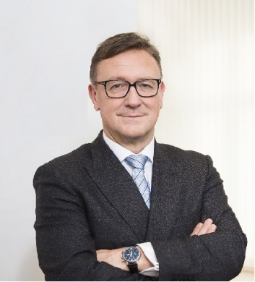 | Calendar of Helmut Ettl  Member of the Supervisory Board of the Single Supervisory Mechanism  Executive Director of the Austrian Financial Market Authority  April 2025
Date | Meeting / Event | Location
Monday, 7 April | Supervisory Board Meeting | Virtual
Thursday, 10 April | Speaker at the EUROFI Conference | Warsaw
Monday, 14 April | Meeting with the media | Vienna
Thursday, 17 April | Meeting with supervised entity | Vienna
Wednesday, 23 April | IIF Annual Membership Meeting | Washington, DC
Wednesday, 23 April | Meeting with representatives of the IMF | Washington, DC
Thursday, 24 April | Meeting with representatives of the SEC | Washington, DC
Thursday, 24 April | Meeting with representatives of the U.S. Department of Treasury | Washington, DC
Thursday, 24 April | Meeting with representatives of the OCC | Washington, DC
Thursday, 24 April | Meeting with representatives of the IMF | Washington, DC
Friday, 25 April | Meeting with representatives of the FDIC | Washington, DC
Friday, 25 April | Meeting with representatives of the FED | Washington, DC
Tuesday, 29 April | Speaker at “Österreichischer Schutzverband der Wertpapierbesitzer” | Vienna

The calendar gives information on Helmut Ettl’s meetings in his capacity as a member of the ECB’s Supervisory Board. It includes institutional meetings, speaking engagements, attendance at conferences and events, as well as appointments with external parties (incl. media), unless releasing the information could undermine the protection of public interests recognised at EU level. Internal Eurosystem meetings are not published.

