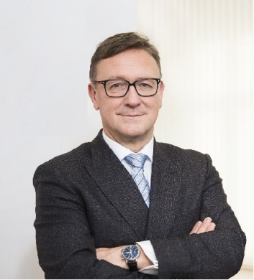 | Calendar of Helmut Ettl  Member of the Supervisory Board of the Single Supervisory Mechanism  Executive Director of the Austrian Financial Market Authority  May 2025
Date | Meeting / Event | Location
Thursday, 15 May | Supervisory Board Meeting | Malta
Friday, 16 May | Supervisory Board Meeting | Malta
Tuesday, 20 May | Speaker at “Finanzplaner Forum” | Vienna
Tuesday, 20 May | Meeting with media | Vienna
Tuesday, 27 May | EBA MB Meeting | Virtual
Tuesday, 27 May | Meeting with supervised entity | Vienna
Wednesday, 28 May | Supervisory Board Meeting | Virtual

The calendar gives information on Helmut Ettl’s meetings in his capacity as a member of the ECB’s Supervisory Board. It includes institutional meetings, speaking engagements, attendance at conferences and events, as well as appointments with external parties (incl. media), unless releasing the information could undermine the protection of public interests recognised at EU level. Internal Eurosystem meetings are not published.

