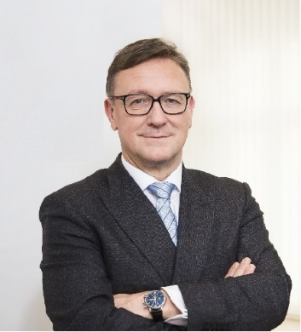 | Calendar of Helmut Ettl  Member of the Supervisory Board of the Single Supervisory Mechanism  Executive Director of the Austrian Financial Market Authority  June 2025
Date | Meeting / Event | Location
Wednesday, 4 June | Financial Markets Stability Board Meeting | Vienna
Thursday, 12 June | Supervisory Board Meeting | Virtual
Friday, 13 June | Supervisory Board Meeting | Virtual
Tuesday, 17 June | Steering Committee of the Supervisory Board Meeting | Virtual
Tuesday, 17 June | Interview with media | Vienna
Monday, 23 June | Interview with media | Vienna
Tuesday, 24 June | Participation in the Financial Committee Meeting of the Austrian Parliament | Vienna
Wednesday, 25 June | EBA Board of Supervisors Meeting | Paris
Thursday, 26 June | Speech at the Internal Auditors Committee (IAC) Meeting | Vienna
Thursday, 26 June | Interview with media | Vienna
Monday, 30 June | Interview with media | Vienna

The calendar gives information on Helmut Ettl’s meetings in his capacity as a member of the ECB’s Supervisory Board. It includes institutional meetings, speaking engagements, attendance at conferences and events, as well as appointments with external parties (incl. media), unless releasing the information could undermine the protection of public interests recognised at EU level. Internal Eurosystem meetings are not published.

