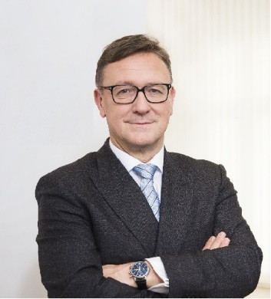 | Calendar of Helmut Ettl  Member of the Supervisory Board of the Single Supervisory Mechanism  Executive Director of the Austrian Financial Market Authority  October 2023
Date | Meeting / Event | Location
Monday, 2 October | Financial Markets Stability Board Meeting | Vienna
Tuesday, 3 October | Speech at an event organized by OeNB | Salzburg
Wednesday, 4 October | Speech at an event organized by ELEC | Vienna
Thursday, 5 October | SB Strategic Retreat | Rome
Thursday, 5 October | SB Meeting | Rome
Friday, 6 October | SB Meeting | Rome
Monday, 16 October | Interview with media | Vienna
Monday, 16 October | Meeting with supervised entity | Vienna
Tuesday, 17 October | EBA BoS Meeting | Paris
Wednesday, 18 October | Meeting with the Austrian Chamber of Commerce | Vienna
Thursday, 19 October | SB Meeting | Virtual
Friday, 20 October | SB Meeting | Virtual
Monday, 30 October | Meeting with supervised entity | Vienna

The calendar gives information on Helmut Ettl’s meetings in his capacity as a member of the ECB’s Supervisory Board. It includes institutional meetings, speaking engagements, attendance at conferences and events, as well as appointments with external parties (incl. media), unless releasing the information could undermine the protection of public interests recognised at EU level. Internal Eurosystem meetings are not published.

