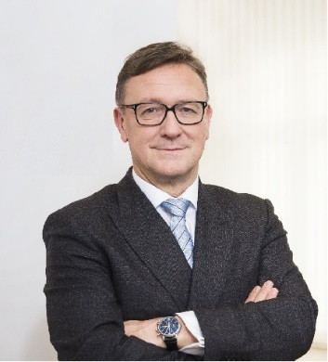 | Calendar of Helmut Ettl  Member of the Supervisory Board of the Single Supervisory Mechanism  Executive Director of the Austrian Financial Market Authority  August 2023
Date | Meeting / Event | Location

The calendar gives information on Helmut Ettl’s meetings in his capacity as a member of the ECB’s Supervisory Board. It includes institutional meetings, speaking engagements, attendance at conferences and events, as well as appointments with external parties (incl. media), unless releasing the information could undermine the protection of public interests recognised at EU level. Internal Eurosystem meetings are not published.

