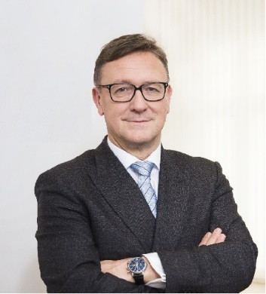 | Calendar of Helmut Ettl  Member of the Supervisory Board of the Single Supervisory Mechanism  Executive Director of the Austrian Financial Market Authority  November 2023
Date | Meeting / Event | Location
Tuesday, 7 November | IAIS Annual Conference | Tokyo
Wednesday, 8 November | IAIS Annual Conference | Tokyo
Thursday, 9 November | IAIS Annual Conference | Tokyo
Friday, 10 November | EBA BoS Meeting | Virtual
Monday, 13 November | Meeting with representatives of the U.S. Department of Treasury | Washington, D.C.
Monday, 13. November | Meeting with a representative of the World Bank | Washington, D.C.
Tuesday, 14 November | Meeting with Commissioners of the U.S. Securities and Exchange Commission | Washington, D.C.
Tuesday, 14 November | Meeting with representatives of the IMF | Washington, D.C.
Tuesday, 14 November | Meeting with representatives of the Office of the Comptroller of the Currency | Washington, D.C.
Wednesday, 15 November | Meeting with the FDIC Vice Chair | Washington, D.C.
Wednesday, 15 November | Meeting with representatives of the FED | Washington, D.C.
Wednesday, 22 November | Meeting with supervised entity | Vienna
Thursday, 23 November | EBA MB Meeting | Paris
Monday, 27 November | Meeting with supervised entity | Vienna
Tuesday, 28 November | Meeting with private sector | Vienna
Wednesday, 29 November | SB Meeting | Frankfurt
Thursday, 30 November | ECB Forum on Banking Supervision | Frankfurt

The calendar gives information on Helmut Ettl’s meetings in his capacity as a member of the ECB’s Supervisory Board. It includes institutional meetings, speaking engagements, attendance at conferences and events, as well as appointments with external parties (incl. media), unless releasing the information could undermine the protection of public interests recognised at EU level. Internal Eurosystem meetings are not published.

