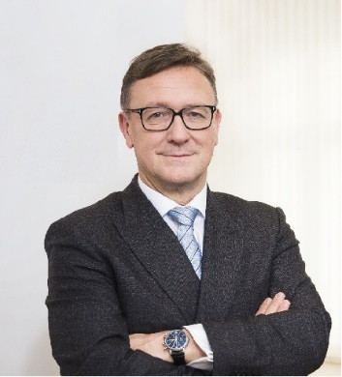 | Calendar of Helmut Ettl  Member of the Supervisory Board of the Single Supervisory Mechanism  Executive Director of the Austrian Financial Market Authority  December 2023
Date | Meeting / Event | Location
Wednesday, 6 December | Press Conference on “Facts and Figures, Trends and Strategies 2024” | Vienna
Thursday, 7 December | Meeting with supervised entity | Vienna
Friday, 8 December | SB Telco | Virtual
Monday, 11 December | Financial Markets Stability Board Meeting | Vienna
Tuesday, 12 December | EBA BoS Meeting | Virtual
Thursday, 14 December | Speech at the 20th China International Finance Forum | Shanghai

The calendar gives information on Helmut Ettl’s meetings in his capacity as a member of the ECB’s Supervisory Board. It includes institutional meetings, speaking engagements, attendance at conferences and events, as well as appointments with external parties (incl. media), unless releasing the information could undermine the protection of public interests recognised at EU level. Internal Eurosystem meetings are not published.

