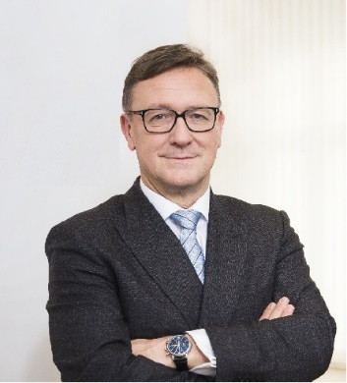 | Calendar of Helmut Ettl  Member of the Supervisory Board of the Single Supervisory Mechanism  Executive Director of the Austrian Financial Market Authority  July 2023
Date | Meeting / Event | Location
Tuesday, 4 July | Meeting with the Chair of Bankers’ Association | Vienna
Wednesday, 5 July | Meeting with Supervised Entity | Vienna
Wednesday, 5 July | Macroprudential Forum Meeting | Virtual
Monday, 10 July | EBA Away Day | Malaga
Tuesday, 11 July | EBA Away Day | Malaga
Wednesday, 12 July | Supervisory Board Meeting | Frankfurt
Thursday, 13 July | Supervisory Board Meeting | Frankfurt
Monday, 17 July | Meeting with Supervised Entity | Vienna
Thursday, 20 July | Meeting of the Steering Committee of the Supervisory Board | Virtual
Thursday, 20 July | Meeting with private sector | Vienna

The calendar gives information on Helmut Ettl’s meetings in his capacity as a member of the ECB’s Supervisory Board. It includes institutional meetings, speaking engagements, attendance at conferences and events, as well as appointments with external parties (incl. media), unless releasing the information could undermine the protection of public interests recognised at EU level. Internal Eurosystem meetings are not published.

